**Chapter 2**

**Review of Literature**

A literature review or narrative review is a type of [review article](https://en.wikipedia.org/wiki/Review_article). A literature review is a [scholarly paper](https://en.wikipedia.org/wiki/Scholarly_paper), which includes the current knowledge including substantive findings, as well as theoretical and methodological contributions to a particular topic. Literature reviews are [secondary sources](https://en.wikipedia.org/wiki/Secondary_sources), and do not report new or original experimental work. Most often associated with academic-oriented literature, such reviews are found in [academic journals](https://en.wikipedia.org/wiki/Academic_journals), and are not to be confused with [book reviews](https://en.wikipedia.org/wiki/Book_reviews) that may also appear in the same publication. Literature reviews are a basis for research in nearly every academic field. A narrow-scope literature review may be included as part of a [peer-reviewed](https://en.wikipedia.org/wiki/Peer_review) journal article presenting new research, serving to situate the current study within the body of the relevant literature and to provide context for the reader. In such a case, the review usually precedes the methodology and results sections of the work.

1. **Face Recognition Techniques to Differentiate Similar Faces and Twin Faces.**

In computer technology image based on identical twin, face recognition technology is challenging task. Traditional facial recognition system exhibit poor performance in differentiating identical twins and similar person under practical conditions. The following methods for differentiate identical twins.Traditionally lot of manual experiments were performed to identify twins and also to recognize their features with difference, and many more systems were existed to show differences in twins by using finger prints, voice and iris as part of pattern recognition. In existing methods, many techniques are used for twin’s identification like finger print, voice and iris recognition [1].

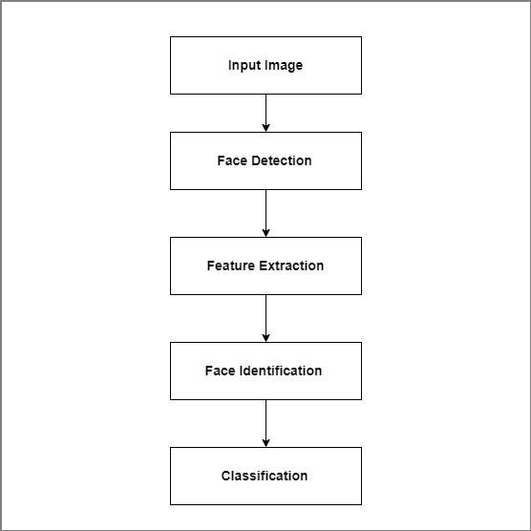

Figure 2.1: System Architecture for Face Recognition Technology.

The process of finger print identification is used to identify unique person in industry or organizations.The method propose a scan image taken from the person and compare with database for identification. The iris recognition also similar method to finger prints identification [1].

Conclusion of this paper to identify the twins and similar faces using Gabor filter and Multi-scale Fast Radial symmetry transform. Gabor filter is used to differentiate when faces are not similar. But multi-scale Fast Radial SymmetryTransform technique is used to differentiating identical twins and similar faces using facial aspects. This method gives good performance compare than Gabor filter method [1].

1. **Secure Authentication for Mobile Banking Using Facial Recognition**

In the past decades, banking was done inside the banking hall which was tasking to both the customers and the bankers. The long queues, paper-based data and even the time taken to perform even the smallest transaction can be an uphill task. This has now been a thing of the past since the advent of the internet and mobile phones. The number of online banking users has increased in Nigeria and indeed the world; this has led to many experts in mobile banking software and mobile phone technology to research new and convenient methods for customers to perform banking transactions remotely via their mobile phones. Mobile banking is also known as mobile phone bank. It is referred to as the using mobile phone for banking related business. Security has become a primary concern in order to provide protected mobile transaction between the clients and the bank servers. Secure authentication of client information depends on some fundamental security approaches which will not jeopardize the client sensitive information. This has led to different researches ranging from single-factor authentication, two-way authentication, and multifactor authentication. Bearing in mind the cost of providing these services to clients, most banks are weary of balancing profit making and security. In Nigeria today, most mobile banking applications use the single-factor authentication which consist of the username and password. Secure mobile banking will build confidence in customers knowing that their information is secure and they can carry out secure transactions without fear of man-in-the-middle attacks. Though the issue of theft strongly depends on how a client protects his/her mobile phone device from third parties [2].

The proposed system is expected to provide higher level of authentication (multifactor authentication) which will bring unauthorized access to the barest minimum. Before access will be granted, the user will have to take a facial photograph to have access to his/her account, the geometry of the face, distance of the eyes and the nose is compared. This photograph will be compared with the photograph in the bank server and the NCC server for verification, if it passes the verification, access will be granted, otherwise it will denied. In the event of unauthorized access, a security alert message will be sent to the bank[2].

On the program end, the security is multi-factored. A username and password level, a facial recognition level and a secret question and answer level. Users are limited to five trials after which access is denied. The response time for a complete transaction is seven minutes maximum putting other limiting factors into consideration; the false acceptance rate is 3%.the implication of false acceptance rate is given by elements on image background and facial defects [2].

The advantages of this system include;

i. Secure and transaction

ii.Cost effective

iii.Transaction can be done anywhere remotely (with availability of mobile network)

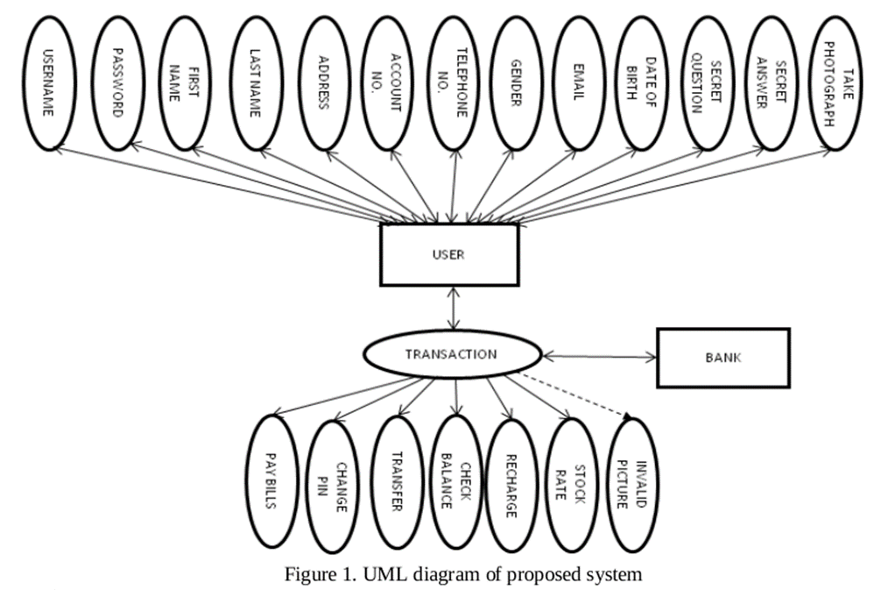

Fig.2.2: Flow of proposed system [2]

In Fig. 2.2 two dependable databases are also used to authenticate genuine users; these databases are the NCC database and the issuing bank database. In an advent of facial defection, users are advised to see their bank information technology operators.

When the security is trusted, it will build customer satisfaction and discourage the use of cash. The number of mobile phone users increases by the day and the success of the security on mobile banking will encourage new users to adopt the trend. Introducing this level of authentication using facial recognition on users’ account to authenticatefrom the Nigeria Communication Commission’s database and the facilitating bank’s database, will no doubt contribute to mitigate mobile banking fraud.In a bid to make the Nigerian economy cashless, attention should be focused on security [2] .

1. **Biometric Face Recognition Payment System**

Use of payment cards in various places such as shopping, restaurants, lodges and online payment for booking hotels, movie tickets, flight and train tickets etc are increasing day by day. Therefore, the problem is that a person has to carry payment cards along with him and keep the cards secure to use it all the time. This also lacked security. In the present work the biometricface recognition payments is used in all kinds of payments. Thus, it avoids the need to memorize different passwords.

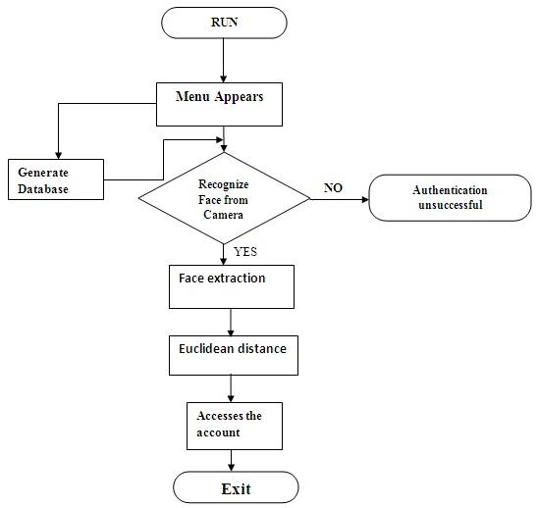

Fig 2.3:Biometric face recognition payment system [3].

Face recognition payment system is safe, secure and even easy to use.It is reliable and more efficient compared to other payment technologies. A general design of online payment system using face recognition is proposed. The methods adopted for facerecognition are by finding the Eigen faces and Euclidean distance [3].

In this paper, the biometric face recognition based payment system is used in all kinds of payments. For any online payments, the user need not use debit or credit card. A person need not carry card and remember the password for the transaction. Face recognition system is being proposed for all transactions. This is found to be more safe, secure and even easy to use [3].